Background
The idea of establishing a joint working group was initiated during 1999, having the first workshop on this topic in September 1999 in Amersfoort in the Netherlands. Mr. Erik Lysen (PVPS) and Mr. Lex Boselaar (SHCP) chaired this workshop. The workshop concluded that this was the first time that the experts from the SHCP and from PVPS got together and discussed this important topic, and it was agreed to initiate a joint working group between the two implementing agreements. Minutes from this workshop are available on request. A second workshop was discussed in connection with the conference Renewable Energy for the New Millennium in Sydney, March 2000, but was cancelled due to the fact, that to few participants from the SHCP-community could be expected to be present.

The present document contains the minutes from the kick-off meeting of the work of the joint working group, held in Copenhagen Denmark, 23 June 2000. Co-ordinator of the meeting was Mr. Henrik Sørensen, Esbensen Consulting Engineers, DK, who is also the activity leader of IEA PVPS Task 7 activity 2.5 on PV/T-collectors.

Minutes of the meeting are circulated to all participants of the meeting, the Exco-members of SHCP and PVPS and to the participants of the first workshop in Amersfoort, NL.

Participants
Participants for the meeting were appointed and invited via the Exco-members of SHCP and PVPS:
A full list off appointed experts is listed in Annex A.

The following experts participated in the meeting:

Country | Name | Organisation | e-mail address
Denmark | Henrik Sørensen  Lars Thomsen Nielsen | Esbensen Consulting, Copenhagen  Esbensen Consulting, Copenhagen | h.soerensen@esbensen.dk, co-ordinator  l.t.nielsen@esbensen.dk
Israel | Ami Elazari | Amitec Information Industries Ltd. | solor@netvision.net.il
The Netherlands | Frederik Leenders | Ecofys | f.leenders@ecofys.nl
South Korea | Jong-Ho Yoon  Jun-Tae Kim | Korea Institute of Energy Research  Kongju University | yesru@kier.re.kr  jtkim@kongju.ac.kr
Sweden | Björn Karlsson | Vattenfall | bjorn.karlsson@utveckling.vattenfall.se
Switzerland | Daniel Ruoss | Enecolo AG | info@enecolo.ch
Observers
Australia | Morgan Bazilian | University of New South Wales | morganbazilian@yahoo.com
Denmark | Yakov Safir | RAcell | safir@racell.dk

Agenda
A copy of the full agenda of the meeting is shown in Annex B. Here the main headlines are listed and used in headings of the minutes from the meeting:

- Short presentation of the status of PV/T Systems in each country
- Identification of common problems and R&D needs
- Roadmap-strategy and organisation of the group
- Commitment for participation and funding possibilities
- Any other business
- Conclusions and action plan

Short presentation of the status of PV/T Systems in each country
(Countries listed in alphabetical order)

Australia (Morgan Bazilian as observer)
Recently there has been a great deal of attention focused on building integrated PV solutions in Australia. This has culminated with the Olympic Housing Project at Homebush, where over 600 homes will be installed with a 1kW integrated PV system and an integrated solar hot water system as well. (The two systems are running independent of each other.) The project is a good precedent in Australia for integration of solar systems in sloped roofs. It is a high profile project and has already attracted world-wide interest. The Olympic project highlights the need for both solar electrical and thermal production in the residential market. There are a number of Organisations working on BiPV including SOLARCH and the PV Research Centre at the UNSW. Solar hot water installations have a good market penetration in Australia and a long history.

Work on combined PV/T concepts is currently limited to research projects. There are projects addressing the residential and commercial integration of PV/T at the UNSW. There is also a project investigating larger utility-scale concentrator PV/T applications being conducted in Victoria. Solar energy has a well-established market in Australia and a reasonable per capita use factor. The advancement in PV/T research and products will necessitate a better communication link between the solar thermal and solar electrical industries and experts. It is currently, however, in its infancy. Studies will need to look at niche markets in Australia’s varied climatic zones.

Denmark
PV-research in Denmark is generally concentrated around application and use of PV in building integrated systems. Focus has been on added values and PV/T-systems are one example of the added value, which can be obtained by PV when looking at traditional thermal collectors.
Currently one specific research project has been initiated within the framework of the EFP-programme (Energy Research Programme). The project is co-ordinated by Ivan Katic from the Danish Solar Energy Centre, and Novator (Bent Sørensen) and Esbensen (Henrik Sørensen) are participants.
The first Danish PV/Thermal collector developed by the companies RAcell and Batec is currently being tested according to the standard tests for new thermal collectors for the Danish market. If the test turns out to fulfil the requirements the product is likely to be marketed during the coming year.

Israel
Mr. Ami Elazari presented a status of the Israeli situation and examples of application of a specific PV/T-collector, some of which have been in operation for 9 years and should be economical feasible in the Israeli climate and energy price condition. The product (Multi-Solar PV/T/air is described in the recent paper presented at the Eurosun2000 conference in Copenhagen and attached here in Annex C. In the paper the annual energy balance and key economical figures are presented. Generally a simple payback period of down to 3 years is achievable and the additional costs of PV, compared to the thermal collector system with water and air as media is down to 3 US$/W_{p}.
The product has been patented in US and in other countries and experiments of different kinds have been carried out, also within the framework of the European Commission EUREKA-program. International collaboration also exists with participants from Turkey, The Netherlands and Denmark.
A test-rack with the system exists and 6 different applications are currently being equipped with data-loggers. A large contract of 200 systems to the UN was signed but realisation had to be postponed due to the Gulf-war. Application of the systems cover public showers and energy supply for individual housing but also new project is planned with an application for solar cooling.
So far only monitoring exist for Israeli conditions and it would be interesting to normalise these to other climates and specific values.

The Netherlands
Mr. Frederik Leenders presented the main conclusions from the workshop in Amersfoort, see Annex D. The Netherlands are probably the most active country in Europe in the field of PV and are interested in PV/T systems for several reasons. Efficiency per area unit and the potential saving of materials compared to the situation with separate collectors are important arguments.

South Korea
Solar thermal has being prioritised for a period due to the long-terms research programmer initiated 1998. Target is that by the year 2006 2% of the total energy consumption should be covered with solar energy. Currently 3.2 MW Photovoltaic systems exist, primarily as stand alone systems. Recently increased interest has been shown by industry to develop BIPV-modules, which are likely to be based on thin-film type PV. Currently 180,000 Solar thermal installations exist, most of which are based on heat pipe collectors. Currently 5 companies are active in the PV sector, but other electronic industry are interested and can relatively change production. A new 3-year project has been started to develop sealed glazing units with integrated PV.

Spain
Unfortunately it was not possible for the Spanish participant (Mr. Alfonso de Julian) to attend the meeting in Copenhagen. A report was forward via e-mail and is attached here in Annex E. In the report no specific PV/T installations or products are mentioned, but the general conditions for PV in Spain is explained being promising. Compared to e.g. the Israeli climate PV/T systems are likely also to be attractive in the Spanish market.

Sweden
Mr. Bjørn Karlsson (Wattenfall) presented concentrating systems for PV/T which is a quite different approach to the most common flat plate absorber based PV/T systems. The first generations of the absorber has been developed for thermal systems, where a parabolic asymmetrical reflector of anodised Aluminium directs sunlight to the relatively compact absorber, receiving Sunlight on both sides. Because of the design of the reflector an adjustment is needed around 5 times per year to compensate the changing solar heights from Winter to Summer. Due to the asymmetrical design the design is best suited for the Northern Hemisphere. For a Scandinavian condition the system produce around 250 kWh/m² solar cell area whereas a usual high performing solar system will produce around 100 kWh/m². The temperatures on the absorber can rise up to 150 °C during stagnation and generally the temperatures rise quickly. If this thermal energy would be utilised the total system performance per square meter collector area could rise up to a factor of 4 compared to traditional separated systems, and the payback time would then being close to feasible, since the price would be around 200 US$/m².
A facade has been designed with the system as a large test system and Bjørn Karlsson is interested in also providing collectors for the purpose of testing in laboratories.

Switzerland
Mr. Daniel Ruoss (Enecolo) presented the status of an ongoing, quite comprehensive R&D-programme on PV/T carried out by a group of Swiss companies co-ordinated by EPFL- LESO. Phase 1 included a feasibility study and phase 2 has just been concluded. One of the main conclusions in phase 1 was the recommendation not to base the development of PV/T systems on crystalline solar cells, due to the effect of reduction in electrical yield with increased temperature of the cells. Another finding of this study is the need of at least 80% in total absorption is necessary for PV/T absorbers to obtain economical feasible systems for average central European climate conditions. Phase 2 was focusing on the measurements of the absorption coefficient, the thermal behaviour induced by high temperature up to 210°C and the emissivity of several different samples.
The feasibility study and the phase 2 report are quite detailed and can be recommended to other experts as background material.
An eventually Phase 3 will concentrate on measurements of thermal yield, stability towards temperature fluctuations, where the encapsulation material seems to be critical. Among other issues the aim of phase 3 is to improve the emissivity and the covering material of the solar cells. So far no specific manufacturer of the solar cells has been identified.

Identification of common problems and R&D needs
Based on an open discussed based on the individual experts needs and experiences the following topics were regarded being of common interest to be investigated within the framework of an international collaboration. The order of the sections below does not necessarily indication the order of sequence in which the working group should treat them.

State of the art and collection of basic specifications
Work has already been started on the analysis and development of PV/T systems and actions are needed to collect and distribute this to the rest of the working group:

Actions:
- Start listing what does the designers need to know
- Quantify the specifications for known systems and concepts
- Inventory from IEA PVPS Task 7, activity 2.5 should be further developed and missing data collected.
- Bibliography with primary literature on PV/T is needed. Frederik Leenders (NL) and Morgan Bazillian (AUS) agreed to collate the lists they have collected and forward to the group.

Performance evaluation
So far no common evaluation standards exist for the evaluation of PV/T systems. A number of activities is needed to develop a common basis for performance evaluation of PV/T

Activities:
- Definition of performance of PV/T systems
- Ways of normalisation of performances
- Definition of parameters: climate, user profile, system key-values etc.
- Should be normalised according to typical design parameters.
- Comparison with existing standards to find suitability
- Identification of good tools for simulation
- TRNSYS?
- Exergy calculation based model (Japan)?
- JRC recommendations?
- University of Cardiff and Strathclyde?
- Calculations (simulation) and testing of specific system with known performance under various situations.

Stability of material (known materials)
The lamination technologies of PV and other mounting principles from PV and Thermal applications should be investigated further, since the materials in the combined systems typically are exposed to more extreme situations than in traditional applications. Especially the influence of high temperatures and lamination and performance of mono- and polycrystalline solar cells is interesting to clarify.

Activities:
- Testing by other groups?
- Considered Important especially for Switzerland, Denmark, Sweden

R&D-topics in order to optimise performance
Based on better knowledge about the overall performance of the various systems activities should be initiated to identify critical parameters and target the development or improvement of the systems:

Activities:
- Identify critical parameters, components, controls etc.
- Optimisation of the performance with optimum use of the energy production
- Thermal interaction between solar cells and absorber, especially the physical contact where electrical isolation is needed and at the same time a high heat conductivity is needed
- Study of the importance of backside reflection of solar cells laminated to absorbers, since the radiation penetrating the cell know can be used as thermal source.
- Utilisation of new optical components to improve efficiency
- Analyse possibilities to use other types of spectral selective layers

Testing methods to be used?
So far the testing of PV/T systems at laboratories are conducted either strictly according to standards for testing of thermal solar collectors, but depending on the power produced and the load connected, different results for the same PV/T system may occur.

Actions:
- Guidelines needed (climate independent)
- Start with a standard thermal test and test PV performance for different temperatures
- Facilities are available in Switzerland and Denmark (and other countries as well), but funding is needed.

Markets (all participants in working group should contribute)
The analysis of markets is crucial for the development of new products. The analysis can be split in principally two different issues: technical and economical. The following actions consider the more technical issues to analyse the technical potential to use PV/T systems:

Actions:
- Case study for Israel based on the Multi Solar product, analysed for a few selected reference cases and general applications
- Could be analysed for climate conditions such as Netherlands, Israel, Spain...
- Methodology developed in The Netherlands to evaluate systems against 10 criteria. Could be used as starting point for the market analysis for PV/T systems

Economy
A number of different economical key-values were considered important to calculate for PV/T systems:

Actions:
- Identify which economical key-values should be used to describe PV/T systems versus separate systems (data from other tasks in SHCP and PVPS).
- Evaluate the market according to the buyers preference
- Typical key-figures:
- $/kWh_{(annual)} thermal production price at a certain temperature demand
- $/m² investment costs
- kWh_{(annual)} / m²
- net extra costs for building integration (combined, separate systems)

Aesthetic values
None of the experts present at the meeting believed in a future for PV/T unless the esthetical values are at least as good as for PV and active solar. Given the combination of these two systems, the PV/T systems can principally be made physically smaller, which could be attractive to building designers and clients.

Actions:
- Use the list of evaluation criteria for PV-projects in the built environment from IEA PVPS Task 7 as starting point - eventually add other aspects.

Roadmap-strategy and organisation of the group
At the first meeting in Amersfoort it was decided that the activities of the joint working group should be based around setting up a road map for the development towards market ready PV/T systems. The first step to provide an overview of this roadmap is shown below.

The activities of the working group are illustrated in the centre of the diagram. Purpose of the working group is to catalyse the exchange of information and ideas between the three major players: The building Professionals (Architects, Engineers etc.), the Manufacturers of PV/T systems and the Research Community. At the present stage the information passes through the working group but the objective is to develop the direct communication between the three bodies.

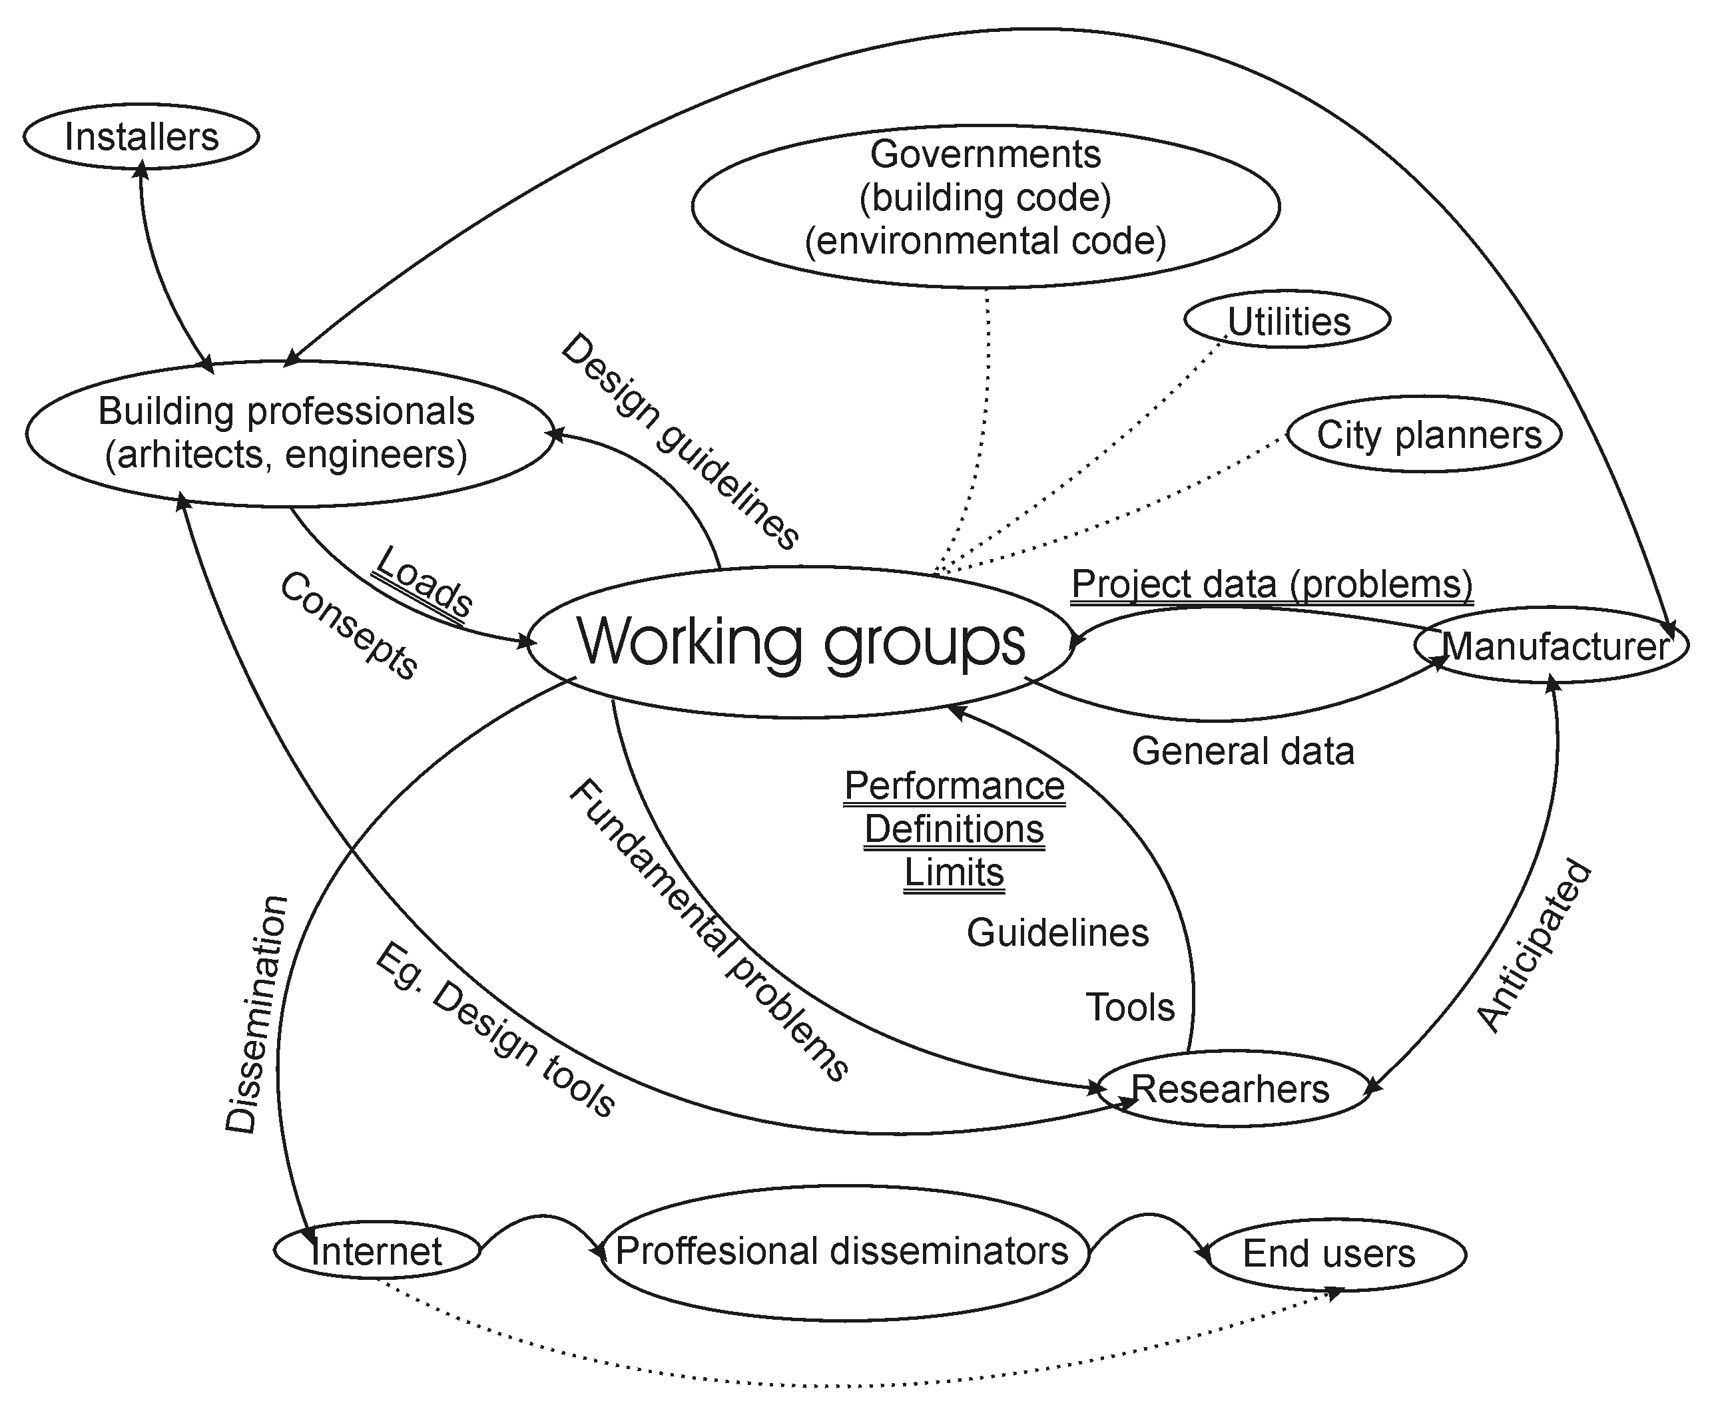

According to the action plan listed in chapter 6, the verbal description will be written during the Summer and distributed to all participants.

Commitment for participation and funding possibilities
None of the countries are currently in the position to commit themselves due to the situation of funding of the work in the joint working group. In short the situation can be described as follows:

Australia
Morgan Bazilian reports back to Martin Green during July 2000 and investigate the possibilities for funding af PV/T activities. Personally Morgan Bazilian is working on a Ph.D. on PV/T systems and is interested to exchange information and stay in contact with the joint working group no matter how the possibilities for official participation via separate funding will be possible. During the present year Australia probably will participate with the funding for Task 7 where overlap exists with activity 2.5 on PV/T systems.

Denmark
The work in the new PV/T research project is in line with the planned activities in the joint working group and funding for co-ordination and work in the different activities are secured for the rest of the year and is very likely to be continued. The Danish manufacturer of PV/T systems is interested in participation and providing test collectors for further analysis and monitoring purposes.

Israel
The government has confirmed the interest in participation and together with private funding the Israeli participation is secured. Link with the ongoing Eureka project will probably be established, and panels for analysis and monitoring will be provided. Main interest will be market analysis and the evaluation of performance under standardised conditions for the Multi Solar product.

The Netherlands
Novem would like to see Dutch participation if certain requirements to the workplan are fulfilled: The analysis of the market, regarding potential and the technical and economical analysis of combined systems, should be included. In principal, Novem is interested in financing part of the development of the roadmap, provided a joint international interest exists. Input from Novem will probably imply that the major Dutch PV/Th players will contribute (and learn!) from the joint working group.

South Korea
Participation depends on the BIPV research programme expected to be launched in the beginning of 2001. The major interest would be the theoretical studies and simulation work.

Sweden
Good possibilities exist for financing. Very interested in the development of the new absorber for concentrating systems. Wattenfall has already an available test site where other products also could be tested. Currently two Swedish absorber manufacturers: TechnoTerm and Anders Plät are possible participants. Students at Wattenfall would also be available for monitoring programmes etc. Mats Andersson (Swedish Task 7 participant) will also be linked to the Swedish participation.

Switzerland
Participation is almost certain due to the strong interest of Switzerland on PV/T. Participants is in discussion, but will probably be Daniel Ruoss (Enecolo) strongly linked to the Task 7 participation or as alternative Andreas Haller (Schweizer) or Pascal Affolter (LESO), but this has to be confirmed. Main interest areas are materials (lamination, improvement of emissivity, heat exchanger, etc.), guidelines and concepts for the building design with PV/T together with comprehensive analysis of performance and identification of the technical and economical limits.

Spain
Situation is not clear but Spanish expert appointed by Exco and funding might already be available. Henrik Sørensen follows up on this.

USA
Some projects already exist, e.g. the project at Applebees. Henrik Sørensen will follow up regarding the US situation for participation.

Any other business
Communication
Practical issues regarding circulation of material discussed. Agreed that Henrik Sørensen uploads a Word documents ver. 6.0 or 97 to the website which will be ready in the beginning of August 2000, which can only be reached through a password. The document should be edited by the participants and e-mailed to the author. There should also be a list with dates and names of participants who have read and edited the document.

All communication will basically happen through e-mail.

Conclusions and action plan
In the table below the primary action items for the coming period are listed.

In the table below the initials of the participants are listed:

MG: Morgan Brazilian, Aus. HS: Henrik Sørensen, DK.
FL: Frederik Leenders, NL DR: Daniel Ruoss, SUI
YS: Yakov Safir, DK LTN: Lars Thomsen Nielsen, DK
JHY: Jong-Ho Yoon, KR JTK: Jun-Tae Kim, KR
BK Björn Karlsson, S

Topic | Action | When | Who
Inventory | Circulate inventory to Korean participants | August 2000 | HS
 | Collect remaining data | August - September 2000 | Input from all to HS
 | Include bibliography of MG and FL | 15. August 2000 | MG+FL to HS
 | Complete version ready | 1. October 2000 | HS to all
Web-site | Set up website on www.task7.org | July 2000 | HS
 | Distribute passwords to all | August 2000 | HS to all
Minutes | Draft version for comments | July 2000 | HS to all
 | Comments from participants | 15. August 2000 | All reply to HS
 | Distribute final version | 20. August 2000 | HS distribute to all + Exco + Amersfoort participants
Road map | Draft of text | 15. August 2000 | FL to HS
 | Draft of detailed illustrations | 15. August 2000 | HS circulates both to all
 | Comments to roadmap | 15. September 2000 | All to HS
 | Final draft (around 10 pages incl. time schedule and deliverables) based on comments | 1. October 2000 | HS to all
 | Approval of road map at meeting | 2. or 6. October 2000 | All
 | Final version ready for approval by Exco | 15. October 2000 | HS to all + Exco
Next meeting | Circulation of agenda and invitation | 15. August | HS to all + Exco + Amersfoort participants
Dates reserved:
Monday 2. October
Friday 6. October
Next Exco-meeting |  | Mid. November 2000

Co-ordinator: Henrik Sørensen
Head of Branch Office
Esbensen Consulting Engineers
Vesterbrogade 124 B
DK-1620 Copenhagen V
Tel.: +45 33 26 73 04 (direct)
Tel.: +45 33 26 73 00 (switch board)
Mobile: +45 20 92 67 22 (incl. sms and voice-mailbox)
Fax: +45 33 26 73 01
e-mail: h.soerensen@esbensen.dk

Time: | Activity: | By:
9.00 - 9.15 | Welcome and introduction to participants | Henrik Sørensen
9.15 - 9.30 | Agenda and plan for the day | Henrik Sørensen
9.30 - 10.45 | National activities  Short presentation from each country  - Who is active in the field of PV/T?  - What research activities have been carried out, are ongoing or are planned?  - What industry and components are present?  - What is considered as main being problems to be solved to overcome the barriers for PV/T systems?  Which field of work is considered to be of main interest to the country? | National representatives
10.45 - 11.00 | Coffee break
11.00 - 12.00 | Discussion:  What are our common problems and R&D needs?  - What are the technical problems and barriers?  - What are the barriers for PV/T to enter the market?  - What research already carried out should be the starting point for the group?  - List of activities and grouping of these into categories  - What should be the main outcome of the activities? | All
12.00 - 12.45 | Lunch at meeting place | All
12.45 - 13.00 | Suggestion for roadmapping process and organisation | Henrik Sørensen
13.00 - 14.45 | Discussion and decision on:  - Organisation of the group  - Which activities of the joint working group can run in parallel and which activities should be successive?  - Communication plans, routes and media  - What should be the deliverables of the work? | All
14.45 - 15.00 | Coffee break | All
15.00 - 15.15 | Commitment for participation - funding possibilities  - On what conditions and when can commitment for participation be given from each country?  - Contribution from industry?  - National and international R&D programmes  - Other possibilities? | National representatives
15.15 - 15.30 | Any other business | Henrik Sørensen
15.30 - 16.00 | Action Plan and Conclusions | Henrik Sørensen
16.00 | Closing of meeting  Taxi-transport to Copenhagen Airport will be booked  Optional: Dinner in Copenhagen for participants with late departure or staying overnight in Copenhagen.

SHCP and PVPS EXCO-members before the meeting appointed the following experts.
Further experts are expected to join the work of the group during the coming year:

Country | Name | Organisation | e-mail address
Denmark | Henrik Sørensen  (Lars Thomsen Nielsen) | Esbensen Consulting, Copenhagen  Esbensen Consulting, Copenhagen | h.soerensen@esbensen.dk, co-ordinator  l.t.nielsen@esbensen.dk
Germany | Roland Sillmann | Fraunhofer Institute | r.sillmand@isfh.de
Israel | Ami Elazari | Amitec Information Industries Ltd. | solor@netvision.net.il
Japan | Shogo Nishikawa | Kandenko Co. | kdk-k43095@kandenko.tgn.or.jp
The Netherlands | Frederik Leenders | Ecofys | f.leenders@ecofys.nl
South Korea | Jong-Ho Yoon  Jun-Tae Kim | Korea Institute of Energy Research  Kongju University | yesru@kier.re.kr  jtkim@kongju.ac.kr
Spain | Alfonso de Julian (or colleague) | IBERDROLA Group | alfonso.dejulian@iberdrola.es
Sweden | Björn Karlsson  (Mats Andersson) | Vattenfall  Energibanken | bjorn.karlsson@utveckling.vattenfall.se  mats@energibanken.se
Switzerland | Daniel Ruoss | Enecolo AG | info@enecolo.ch
Observers:
Australia | Morgan Bazilian | University of New South Wales | morganbazilian@yahoo.com
Denmark | Yakov Safir | RAcell | safir@racell.dk

The paper “Building Integrated Multi PV/T/a Solar System roof tile” by Ami Elazari is enclosed in a separate pdf-file taken from the EuroSun 2000 CD-Rom: "D:\05 Combined PV Solar Thermal Systems\05_Ami_Elazari_Building_Integrated_Multi_pv_t_a_Solar_System_.pdf"

Conclusions from Amersfoort (Sept. 1999)

State of the Art
- PVPS Task VII PV/Th database
- Research on PV/Th focuses on efficiency improvement

R&D
- Air: low temperature applications
- Water: low & medium temperature applications
- List of research items

Market Needs
- Currently, no need for integrated PV/Th but for combined PV & Th
- Nice appearance, easy to integrate, easy to buy, easy to use, easy to service
- Now:
PV (air) PV & Th PV/Th
&
Th (water) integrated
Parallel combined & optimised

International collaboration
< 5 jr. info exchange (R&D, applications, rules and guide-lines, universal calculation tools etc.
5 - 10 jr. optimised, integrated PV/Th
> 10 jr. fundamental research

⇒ ROAD MAP

ROAD MAP (Concept)

Short Term (< 3~5 jr.)
To create an international environment that enables / convinces industry to develop PV/Th systems.

Tools: Secure information exchange
Establish R&D network
Develop and implement test methods
Define market needs
Assess market potential
Set “PMC’s: Product Market Combinations”
Develop niche markets

Mid term (3 ~ 7 jr.)
To have integrated PV/Th systems on the market that compete with separate PV & solar thermal systems on costs, aesthetics, comfort, …

Tools: (See above)
Generic R&D on critical PV/Th research items
Confidential R&D on PV/Th product developments

Long term (> 7~10 jr.)
To have integrated PV/Th systems on the market that compete with non-renewables.

SPAIN

PV Technology Status and Prospects

Jesús García Martín, Alfonso de Julián
IBERDROLA
* Luis Alberto Calvo and Estefanía Reolid
* External collaborators

General framework

Power generation is dominated by nuclear energy and hydroelectricity, but 75% of primary energy is imported. That is why, utilities realice increasingly the renewable energies (among them, photovoltaic solar energy) are a good solution to increase electricity production and this way Spain could become self sufficient. On the other hand, gas emissions must decrease to achieve the objectives fixed by European Union for the year 2010.

Several Spanish utilities have invested substantially in grid-connected PV projects such as IBERDROLA with a new project to build 1,3 MW plant in Navarra through EHN participation. ENDESA and UNION FENOSA are two of the main partners in the 1 MW Toledo PV plant, which has been operating for several years. The general public perception is positive particularly due to the low visual impact of PV.

In 1999, the total photovoltaic power installed in Spain was around 9 MW (78% isolated systems and 22% grid-connected systems).

In Spain, the number of photovoltaic systems connected to grid have increased in this year due to a new law, which mandates that local electricity utilities must purchase renewable energy supplied electricity at prices set by national authority. Also people are aware that the use of renewable energy (for example, photovoltaic solar energy) is a clean way to eliminate and reduce polluting gases.

NATIONAL PROGRAM

The Spanish Goverment has opted for Renewable Energy to make its contribution to national energy a relevant factor. That is why, in the early Ninties the Renewable Energy Program was planned 1991-2000, whose main objective was to increase the contribution of Renewable Energies to the national energy total.

In the photovoltaic solar energy area, the objective was to increase the installed power of 2.5 MW during the Program. These figures have been easily exceeded and photovoltaic power has increased by 5 MW since the start of it.

However, in spite of this important development, photovoltaic solar energy does not yet make an important contribution to total renewable energies. To promote this type of energy even more, two important measures have been considered, that deeply affect photovoltaic solar energy. An one hand, the approval of Royal Decree 2818/1998 in which incentives were given to electrical energy produced from renewable facilities, especially those conceded to photovoltaic soalr energy, and on the other hand a new Program of renewable energies 2000-2006 currently pending approval, whose main objective is to achieve development of renewable energies to reach 12% in 2010, according to the White Book of European Union.

In this new Plan of renewable energies, the main conclusions regarding photovoltaic solar energy are the contribution of grants to photovoltaic facilities and the establishment of technical specifications to the connection of photovoltaic systems to grid.

R&D and Demonstration

Cells
The Spanish manufacturers of photovoltaic panels are developing and researching new materials and technologies to achieve low costs of modules and to permit this type of energy to come into commercial production.

In a effort to decrease prices, they are focused mainly on thin silicon cells, which can be deposited on module-sized subtrates in integrally-interconnected structures.

Companies like BP Solar, Atersa, Isofotón are developing also modules with differents coulours and sizes, according to needs of users, which can be integrated on roofs.

Inverters
- ENERTRON is an Spanish company that designs and manufactures photovoltaic inverters.

During the last year ENERTRON has manufactured the following converters in the field of photovoltaic applications:
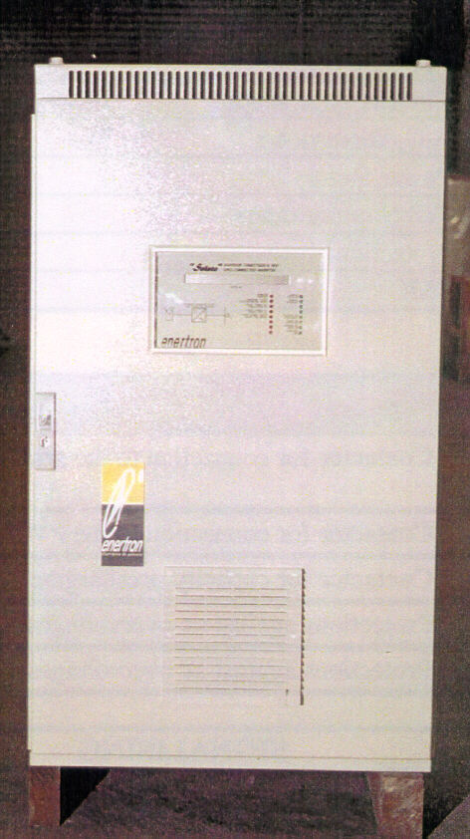

- 1x50KVA DGT inverter and 3x14KVA SOLETE inverters for a photovoltaic plant in Ghana.
- 2x18KVA ACEF-SOLAR inverters for the project “Pérgola fotovoltaica” in the “Palacio de Moncloa” (Presidencia de Gobierno) , Madrid.

In addition to this, within this last year ENERTRON manufactured the first series of the SOLETE inverters for connection to the grid of small photovoltaic plants from 4kVA up to 14KVA.

At this moment ENERTRON is manufacturing the following converters for photovoltaic applications:

- 1x45kVA ACEF-SOLAR inverter for a photovoltaic plant in Alcobendas/Madrid.
- 1x60KVA ACEF-SOLAR inverter for the second stage of the JAEN-UNIVER project.

Solete inverter

- ATERSA is a private company specialized exclusively in photovoltaic technology (modules, regulators, DC/AC inverters)

TAURO inverter has been developed by ATERSA. It is a last generation sine-wave inverter specially designed for grid-connected applications.

TAURO inverter provides a modular solution for grid-connected systems, being adequate for use in building integration because of its low maintenance, low sound level and easy use. This inverter can be modified in case of new applications, in order to form a system open to possible future changes.

IMPLEMENTATION

- "Sunflower Project" (BP-SOLAREX)

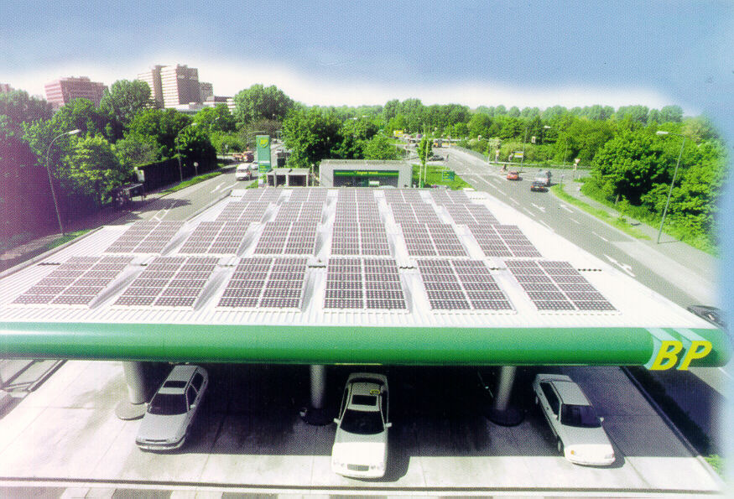
BP Amoco has developed the project " Sunflower ", that calls for the installation of photovoltaic panels in the network of company stations. This project has begun in new stations and the ones that will be rebuilt. To date, the company has already six prepared stations and at the end of this year there will be 22 solar stations of BP Amoco in Spain. In each station they installed an average of 220 solar pannels, each one of them with 36 silicon cells, that turn the solar energy into electrical. The energy thus produced is sent to the local grid in a co-generation process. The generated power is equivalent to about 18 kW, enough to give service to the jets and to the illumination of the station

The installation of this solar system means an average investment by station of about 150602 euros. The annual production for a minimum of 1,000 hours of average insolation would be of about a 18,000 kWh.

"Sunflower" is a global project of BP Amoco that, in its first phase, foresees the incorporation of solar energy in 200 stations of nine countries (Germany, Australia, Austria, Holland, Japan, Portugal, United Kingdom, Switzerland and Spain).

As of result of this project and as a whole, all the network of BP Amoco will obtain a reduction in CO2 emissions of 3,500 tons a year.

BP Solarex, the solar division of energy of BP Amoco, is the company that will provide panels and modules to the stations which are included in the project " Sunflower ".

- Technology Demostration Centre activities on PV systems (IBERDROLA)
Technology Demonstration Centre (TDC) is located in San Agustín de Guadalix, 33,5 km from MADRID.It is divided in three Areas: Renewable Energy Sources, Energy Efficiency and Quality and New Power Generation Technologies. Within the Renewable Energy Area, it is presented a brief look over the systems and works that IBERDROLA has developed in the field of Photovoltaics this year.

a) PV Sound Barrier in a water purification installation
This project consists of the construction of a 8.6 kWp photovoltaic fence in the Technology Demostration Center which IBERDROLA has in San Agustin del Guadalix (Madrid), and whose main objectives are to avoid the negative visual impact of water purification systems and to reduce the noise produced by the operation of these systems.

The main scientific innovation of this project is to show a new application of photovoltaic modules as a constructive element. This way, the photovoltaic module can be considered as a power-generating element and also as a new material for the construction. Also a new inverter developed by a Spanish company will be tested in this project. The use of PV modules instead of conventional construction materials and its integration in buildings or structures, will open a new market for the photovoltaic solar energy. Architects will have a new construction element which is besides a power generator. It will contribute to spread the different applications of grid connected PV systems.

b) New mobile system for the supply of photovoltaic electricity
The main objective of this system is to allow electricity supply to remote customers under service conditions equivalent to those provided by the grid.

There is a former version of 3,3 kW which has been suppliying electricity to a worshopthat specialized in renewable energies for one year. The generated energy is emploied for different activities, like music concerts, in order to demonstrate the reliability of photovoltaic solar energy.

This project consists of the construction of 1.5 kWp portable photovoltaic system. This is the second version made by IBERDROLA, in which one of the most important aspects is a new design of the system. This photovoltaic unit will be formed by a container which due to low dimensions and weight is fit to be transported by plane, train, lorry and boat.

When this container is installed in the chosen place, it can be opened, unfolding the solar field. This operation is designed to be performed by only one person. Inside the container, batteries will be located and also the necessary elements to use the system. At one side of the container, it possible to access to an emergency energy source (fuel engine).
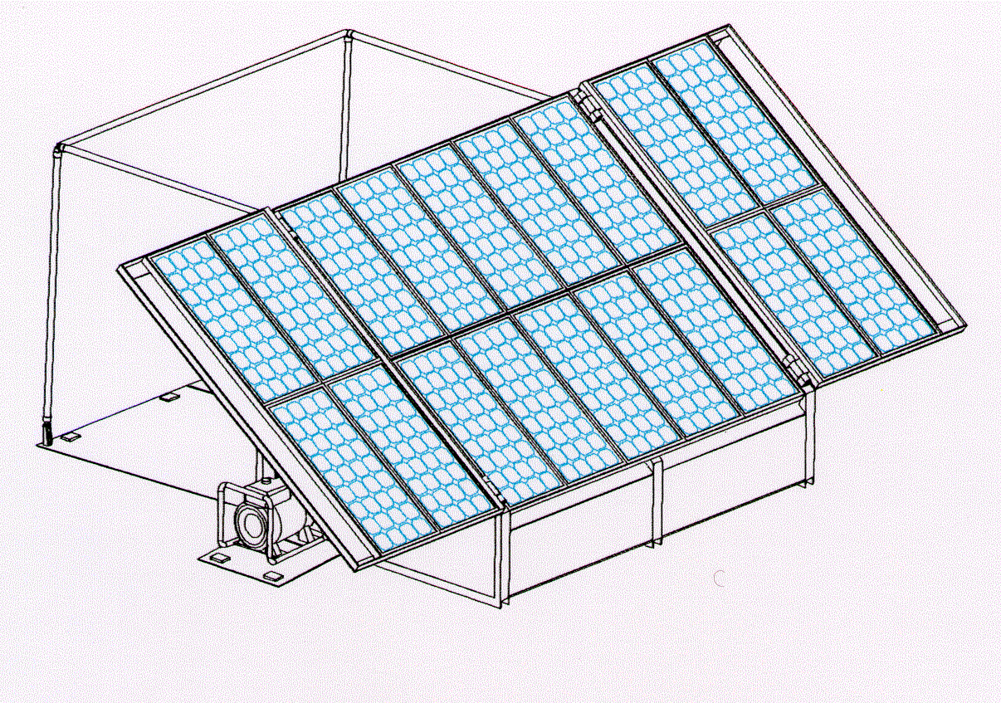
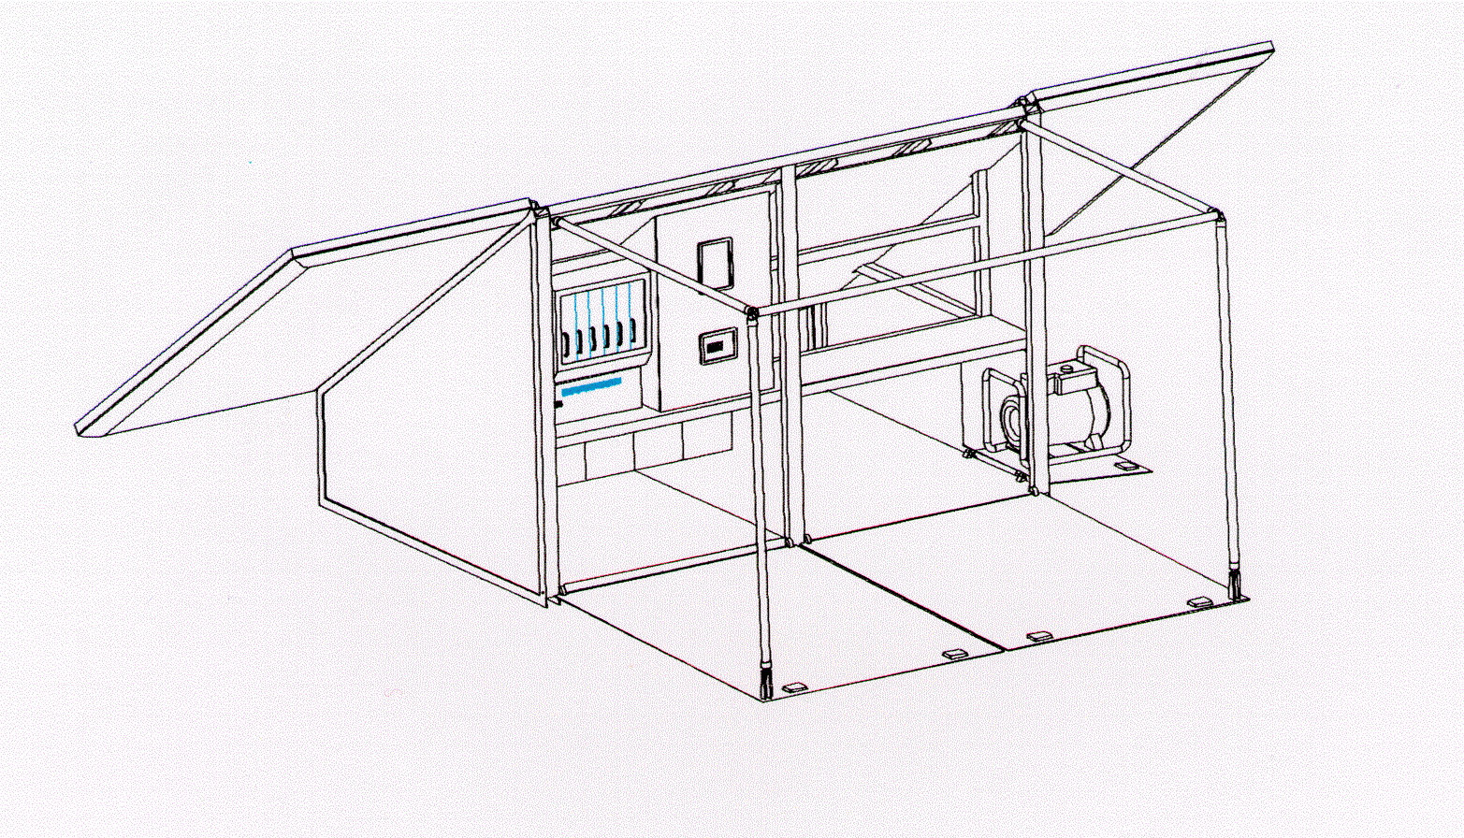

The tallest side of the container folds down and becames available for each uses of the system. Opening this compartment, one has access to the inside of the container, in order to keep specific equipments of each application, for example fridge for medicines, foods, etc…

The main scientific innovation is to design and construct a portable photovoltaic system which can be transported by whatever any kind of transport to be used at sites which are at some distance from the grid. This system not only generates electricity but also can be used as a warehouse and place to work, mainly in underdeveloped countries.

This new prototype is being tested and evaluated at TDC installations.

c) Plug and Play Technology for Hybrid Power Systems (HYBRIX)
This project deals with research in AC coupled systems based on plug and play technology, energy management systems and combination of several energy sources like solar PV, wind, diesel and other options in the future. The intention is to develop a new generation of AC-coupled PV/WIND/DIESEL power supply systems for the introduction into the world-wide rural electrification market. Such systems will be able to cover power needs in the range from some kW up to about 100 kW total installed power.

The proposed system will provide a big degree of modularity in terms of installed power capacity and type of connection while maintaining simplicity and reduced cost for applications in rural areas.

The final prototype of the hybrid power supply system, developed under this project, will be installed and tested at TDC installations.

d) Characterization of new PV technologies at Technology Demonstration Center
Grid-connected PV systems are expected to increase during the next years in Spain due to the profitable economic conditions for this type of installations. That is why, the latest technology of PV roof systems for grid connection are tested in TDC. After the monitoring time of these systems, the TDC will obtain valuable information about their behaviour, in order to introduce these new systems in Spain.

Also, a new technology of AC-modules will be developed under an European consortium. The final product will be analized at TDC in order to verify if this type of PV modules are a reliable future option for grid-connected PV systems.

- Development of a photovoltaic parking for the charging of electric vehicles

This project has been developed by Enerman S.A. and the participation of IBERDROLA, AEMVA and CARTIF.

The objectives of this project consists of the installation of a surface parking structure, in which a grid-connected photovoltaic plant has been integrated. Electric chargers for vehicles have been provided in the botton of that cover. The installation is located in the parking of the Multiple Uses Building in Valladolid The system is also capable of managing a group of electric vehicles.

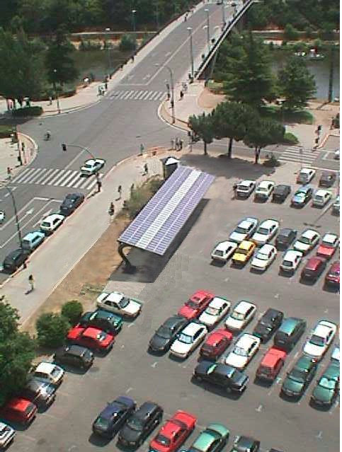The PV array consists of 176 photovoltaic modules with a power installed of 7,5 kWp. The photovoltaic modules are located in a parking structure mainly designed for this project. This structure permits the park of 8 vehicles under the cover.

The inverter is single-phase of the type autoconmuted with IGBT's whose control works like source of current, extracting the maximum available power in the PV array each instant.

Four electric chargers are installed to recharge electric vehicles. For their use, it is necessary to know the access code following several options that appear of the screen of the charger.

This project promotes the building integration of PV systems and the use of electric vehicles through the implantation of suitable infrastructure.

- Centralised generation from photovoltaic in Cuba (ATERSA)
ATERSA is a private company specialized exclusively on photovoltaic technology. They produce a range of PV products including modules, regulators, DC/AC inverters, monitoring systems, etc.. which are manufactured in Valencia. The company has pursued an active policy of increasing their exports, focusing their activities in EU, Africa and LatinAmerica as main markets.

During 1999, Atersa has developed the first centralised power station in Cuba, in collaboration with SERC (Solar Energy Research Centre). The site ( Santa María de Loreto, Cuba) was chosen because of the difficulty of extending the grid in such a mountainous region and the urgent need for a reliable power source to support the rural economy, which is based on coffee and small fruit production.
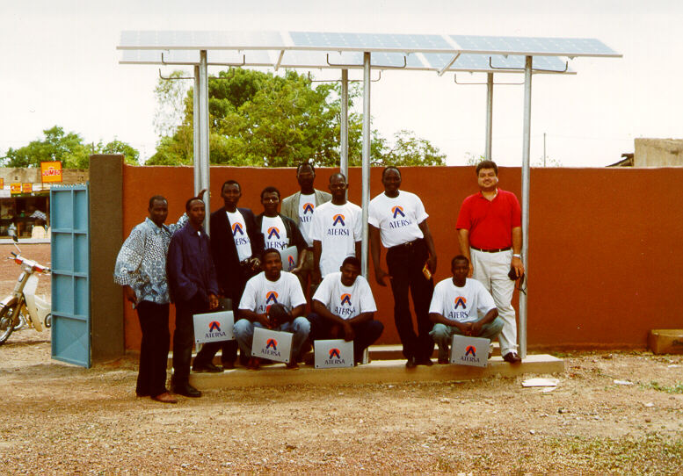

The ATERSA PV system was favoured above other suppliers because of the use of an innovative “ Home Load Limiter ” (HLL) which limits individual consumption and ensures equitable and efficient distribution of the electricity produced. This system had already been successfully demonstrated in Llaveria , Tarragona ( Spain), where an 18 kWp solar PV power station supplies electricity for 47 dwellings, public lighting and the drinking water supply.

The HLL maintains consumption levels within the margins provided for by the system design, only allowing energy consumption to exceed programmed levels when the load status of the system is good. In periods of low tension, the system disconnects any “additional“ consumption .Different limiters can be installer according to the energy requirements of the user, so houses and community services such as public lighting and schools can be supplied by the same PV power station.

The PV system, coupled with the HLL, will provide a reliable and equitable power supply, to help serve the domestic needs of the community´s 250 inhabitants, a primary school, health centre, shop, laundry and coffee processing plant.

Industry status
At present, there are 3 important manufacturers of photovoltaic cells and modules in Spain which are developing new technologies to improve the efficiency and cost. These manufacturers are ISOFOTON, ATERSA, BP-SOLAREX.

The technologies, which these manufacturers are developing, are mainly thin-film cells, concentration cells, and photovoltaic modules to integrate on roofs.

The production of modules and PV cells is represented in the following figure:

Company | Cell Production (MW_{p}) | Module Production (MW_{p}) | Production Capacity (MW_{p}) | Module Type | Additional Information
Atersa | - | 1 | 1.5 | sc-Si
BP Solar España | 4.4 | 4.6 | 10.0 | sc-Si | Involved in cell, module and system manufacture including production of ‘Saturn’ Laser Grooved Buried Grid cells. Modules available in a variety of colours.
Isofoton | 0.643 | 3.37 | 5.0 | sc-Si | Modules from 5 to 110 W_{p} in many different configurations.
Table 1: Modules maufacturers in Spain

Market development
There are three main ways to promote photovoltaic solar energy installations in Spain:

- The Energy Saving and Efficiency Program (PAEE) is run by the different regional governments in Spain. The PAEE subsidises PV installations to a maximum of USD 4.1/W_{p} for on-grid systems and USD 8.2/W_{p} for off-grid systems. PAEE has ended this year, but a new program to promote photovoltaic solar energy is being made and it will be approved next year.

- Also, each Spanish Autonomous Region has developed specific programs to support photovoltaic solar energy. These programs subsidize photovoltaic solar systems (both stand-alone and grid-connected) with a grant of over 25% of the total installation cost.

- The Royal Decree provides an advantageous power rate to kWh produced by photovoltaic solar facilities connected to grid. Utilities must buy photovoltaic electricity at 0,4 EUROS for systems of less than 5 kW and at 0,2 EUROS for systems of more than 5 kW.

Due to these measures of promotion, grid-connected photovoltaic systems are experiencing very important growth, while stand-alone systems show a stabilized market.

FUTURE OUTLOOK
The traditional model, which has served the industry very well the past quarter century, starts with finding opportunities for PV in niche markets. The original niche was space, then terrestrial niches were opened up, for example recreational vehicles, remote telecoms installations and navigational aids. Since then the industry has tried to mobilize government aid to diffuse the technology to others markets and to make it a commercial reality.

Over the long term, innovation is the key to change power business, for example photovoltaics in buildings. Photovoltaics can be installed on a wide range of surfaces and be integrated into materials such as glazing, opening up the possibility of combining energy production with other functions of the building envelope, such as roof and facade integration.

This report has been produced with the collaboration of BP-SOLAREX, ENERTRON, ATERSA., ISOFOTON

IEA SHCP/PVPS Joint Working Program Initial Reference List

Dutifully submitted by Frederik Leenders, ECOFYS, and Morgan Bazilian, SOLARCH

REFERENCES

Affolter P., Haller A., Ruoss D., Toggweiler P. (1996) Absorption and High Temperature Behaviour Evaluation of Amorphous Modules. Report for Project 56360/16868 for the Swiss Federal Office for Energy.

Affolter P., Gay J.B., Haller A., Althaus H., Ruoss D., Toggweiler P. (1997) A New Generation of Hybrid Solar Collectors. Report for Project 56360/16868 for the Swiss Federal Office for Energy.

Affolter P. et al. (2000) Absorption and high temperature behaviour evaluation of amorphous Si. Modules. 16th European PV solar energy Conference, May 1-5, Glasgow. Scotland.

Agarwal R.K., Garg H.P. (1994) Study of a Photovoltaic-Thermal System Thermosyphonic Solar water Heater Combined with Solar Cells. Energy Conversion & Management. 35, 605-620.

Agarwal R.K., Garg H.P., Joshi J.C. (1994) Experimental Study on a Hybrid Solar Photovoltaic-Thermal Solar Water Heater and its Perofrmance Predictions. Energy Conversion & Management. 35, 621-633.

Agarwal R.K., Garg H.P. (1995) Some aspects of a PV/T Collector: Forced Circulation Flat-Plate Solar Ware Heater with Solar Cells. Energy Conversion & Management. 36 (2), 87-99.

Al Harbi Y., Eugenio N.N., Al Zahrani S. (1998) Photovoltaic-Thermal Solar Energy experiment in Saudi Arabia. Renewable energy. 15, 483-486.

Bazilian M., Prasad D. (2000) A Holistic Approach to PV Cogeneration. In Proceedings for EUROSUN 2000, June 19-22, Copenhagen, Denmark.

Becaué C.D. (1997) Warmteterugwinning in HR uitvoering, Verwarming en Ventilatie, mei 1997 no.5.

Benemann, J. (1994) Multifunctional Solar Facades. In Proceedings of First WCPEC, 5-9 December, Hawaii. pp 784-787

Bergene T., Martin Lovvik O. (1995) Model Claculations on a Flat Plate Solar Heat Collector with Integrated Solar Cells. Solar energy, 55 (6), 453-462.

Bhargava A.K., Garg H.P., Agawrwal R.K., (1991) Study of a Hybrid Solar System Solar Air Heater Combined with Solar Cells. Energy Conversion & Management. 31, 471-479

Bloem J.J., van Dijk R., Zaaiman W.J. (1995) Electrical and Thermal Performance Assessment of Hybrid Photovoltaic Systems Using the PASLINK Test Facility. Joule III, PV Hybrid PAS Report, Brussels.

Bloem J.J., Ossenbrink H. (1995) Thermal Aspects of PV Integration in Buildings. The 13th European PV Solar Energy Conference, Nice.

Bloem J.J., van Dijk R., Zaaiman W.J. (1998) Electric Performance Assessment of Building Integrated Hybrid Photovoltaic Systems. Proceedings from the 2nd World Conference on Photovoltaic Solar Energy Conversion, Vienna.

Bollo C. et al. (1995) PV powered solar ventilation system for buildings, 13th European PV Solar Energy Conference, Nice, France, p. 2161 - 2163.

Böttger e.a. (1996) Voorstudie integratie PV modules in vliesgevels, grote glasoverkapte ruimten en zonweringen, Ecofys rapport no. 263, Novem, 146.300-0.37.1, Utrecht.

Brinkworth B.J. et al. (1997) Thermal regulation of PV cladding , Solar Energy Vol. 61, No. 3, pp. 169 - 178.

Brogen M., Nostell P., Karlsson B. (2000) Optical Efficiency of a PV-Thermal Hybrid CPC Module. In Proceedings for EUROSUN 2000, June 19-22, Copenhagen, Denmark.

Chantant M. et al. (1995) Design computations and performance assessment of multifunctional modules, 13th European PV Solar Energy Conference, Nice, France, p. 2206 - 2208.

Clarke J.A. (1997) Appraising the Performance of Building-Integrated PV systems , ESRU University of Strathclyde. (approach PV Hybrid Pas)

Clarke J.A., Johnstone C., Strachan P., Bloem J.J., Ossenbrink H. (1995) Thermal and Power Modelling of the Photovoltaic Façade on the ELSA Building, Ispra. The 13th European PV Solar Energy Conference, Nice.

Cox C.H., Raghuraman P. (1985) Design Considerations for Flat Plate Photovoltaic/Thermal Collectors. Solar energy, 35 (3), 227-241.

Crick et al. (1997) Photvoltaic Ventilated facade system investigation and characterisation, 14th European PV Solar Energy Conference, Barcalona, Spain, p. 2171 - 2174.

Crick F.J. (1995) Prototypes for commercial buildings in Europe, Development, Construction and Testing 13th European PV Solar Energy Conference, Nice, France, p. 2171 - 2174.

Dichler A. et al. (1997) The Oxford Eco House, background to the Oxford Eco house and preliminary results, BP leaflet, MPJ Associates, Haddenham, Buckinghamshire, England

Dunlop E.D. (1998) Hybrid Photovoltaic module for Roof Integration, prepared for First Joule III PV Contractorsmeeting, 5-7 May1998, Brussels.

Eicker U. and M. Gross (1997) PV curtain walls for pre-heating, 14th European PV Solar Energy Conference, 30 June - 4 July 1997, Barcalona. p. 1868 - 1870.

Elazari A. (1997) Multi solar system, Productfolder.

Elazari A. (1997), Combined PV/T multi solar system field experience in Isreal, including Klil village, Alkapot ranche and Suca in the desert recreation village, ISES solar world congress, Taejon, Korea (?)

Elazari A. (1994) U.S. Patent no. 5,522,944, June 4.

Elazari A. (2000) Building Integrated Multi pv/t/a Solar system rroof tile, Eurosun 2000 Preprint, June 19-22, Copenhagen. Denmark.

Fath, H.E.S. (1993) Development of a natural draft solar fan for ventilation of greenhouses in hot climates, Int. J. of Solar Energy, Vol. 13., pp. 237 - 248

Florschuetz L.W. (1979), Extension of the Hottel-Whillier model to the analysis of combined photovoltaic/thermal flat plate collectors, Solar Energy, vol.22, p.361-366.

Fujisawa Toru and Tatsuo Tani (1997), Binary utilization of solar energy with photovoltaic-thermal hybrid collector, ISES solar world congress, Taejon, Korea.

Garg H.P., Adhikari R.S., (1997) Conventional Hybrid Phtovoltaic/ Thermal air Heating Collectors. Renewable Energy. 11, 363-385.

Garg H.P., Adhikari R.S., (1998) Transient Simulation of Conventional Hybrid Photovoltaic/ Thermal Air Heating Collectors. International Journal of Energy Research. 22, 547-562.

Garg H.P., Adhikari R.S., (1999) Performance Analysis of a Conventional Hybrid Photovoltaic/ Thermal Air Heating Collector with Integrated CPC Troughs. International Journal of Energy Research. 22, 547-562.

Garg H.P., Adhikari R.S. (1999) System Performance Studies on a Phtovoltaic/Thermal Air Heating Collector. Renewable Energy. 16, 725-730.

Häusler T., Rogass H. (2000) Latent heat storage on pV. 16th European PV solar energy Conference, May 1-5, Glasgow. Scotland.

Hayne E. and R.Pfluger (1997) Overall performance of hybrid PV Building Components, ISES 1997 Solar world congress, August 24-30 Taejon Korea.

Hayakashi B., K. Mizusaki, T. Satoh, T. Hatanaka (1989), Research and development of photovoltaic/thermal hybrid solar power generation system, ISES Boedapest.

Hegazy A. (2000) Comparitive Study of the Performances of Four Photovoltaic/Thermal Solar Air Collectors. Energy Conversion & Management. 41, 861-881.

Hendrie S.D., P. Raghuraman and C.H. Cox (1981), Liquid photovoltaic/thermal collectors for residential applications, IEEE Photovoltaic specialists conference, Orlando, Florida, p.818-821.

Isidro M.J., Heras M.R. (2000) The Integration of PV Modules Affect To The Indoor Daylighting. In Proceedings for EUROSUN 2000, June 19-22, Copenhagen, Denmark.

Izumi et al (1997) A 3 kW PV Thermal system for home use, ISES 1997 Solar world congress, August 24-30 Taejon Korea.

Kiss G., Kinkead J. Raman M. (1995) Building Integrated Photovoltaics: A Case Study. NREL Publication. NREL/TP 472-7574, Golden, Colorado.

Kondratenko I. (2000) Hybrid BiPV as Environmental Problem Solver. In Proceedings for EUROSUN 2000, June 19-22, Copenhagen, Denmark.

Komp, R., Kinne S. (2000) The Photovoltaic Still: Desalinate Water and Make Electricity at the Same Time. Proceedings for the 2000 ASES Conference, Wisconsin.

Kröni R. (2000) Solarcombi, Combined heat and Power generation with PV. 16th European PV solar energy Conference, May 1-5, Glasgow. Scotland.

Lalovic B, T. Pavlovic and Z. Kiss, J. van Dine (1988), The application of hybrid a-Si:H PV and thermal collectors for different usages. 8th Photovoltaic solar energy conference (CEC), p.280-283

Lalovic B. (1987) A Hybrid Amorphous Silicon Photovoltaic and Thermal Solar Collector. Solar Cells. 19, 131-138.

Leenders F., van der Ree B.G.C. (1999) Photovoltaic/Thermal Systems. From Workshop on PV/Thermal Systems, 17-18 September. Amersfoot, The Netherlands.

Leenders F., van der Ree B.G.C., Helden van der W.G.J. (2000) Technology Review on PV/Thermal Concepts. In Proceedings for EUROSUN 2000, June 19-22, Copenhagen, Denmark.

Leun van der C.J. et al. (1995) Overzicht potentieel actieve zonne-energie, Ecofys, rapport E1036, Utrecht (Novem 143.100-426.0).

Lien A.G., Hestnes A.G. (2000) Visual Studies of Trnasparent PV Elements. In Proceedings for EUROSUN 2000, June 19-22, Copenhagen, Denmark.

Linden G.P. van der en J.M. van Heel (1996) 'Tests aan prototype onafgedekte PV/Thermische collector', TNO - Bouw, Delft, rapportno. 95-BBI-R1666 (Novem no. 146.200 - 057.2)

Lloret et al. (1995) The Mataró public library: a 53 kWp Grid connected Building with integrated PV - Thermal multifunctional modules 13th European PV Solar Energy Conference, Nice, France, p. 490 - 493.

Lloyd Jones D., Watts B. (2000) Effective Use of Building Integrated Photovoltaic Waste Heat: Three Projects. In Proceedings from the 2nd World Solar Electric Buildings Conference, 8-10 March, Sydney.

Loforski J.J. et al. (1982) Design and construction of a hybrid PV (3 kWP) thermal solar energy system for a residential / commercial building, IEEE PV Spec. Conf, 16, 188.

Luque A., Marti A. (1999) Limiting Efficiency of Coupled Thermal and Photovoltaic Converters. Solar Energy Materials & Solar Cells. 58, 147-165.

Marko A (1995) VDI Fortschritt berichte, Kapitel 4, Thermisch - Photovoltaischer Hybridkollektor, p. 85-95

Marshall R. and Z. Ibarahim (1997) 'Simplified loop analysis for naturally ventilated buildings' University of Cardiff, Dept. of Mech. Eng., Cardiff, England

Michel. E. et al. (2000) Design, Realization, Tests, Comparative analyis of low electric consumption PV cooling systems. 16th European PV solar energy Conference, May 1-5, Glasgow. Scotland.

Miyazaki (1996) Solar Multi module for electrical and hot water supply for residentially building, Int'l PVSEC-9, Japan

Moshfegh B., Sandberg M., Bloem J.J., Ossenbrink H. (1995) Analysis of Fluid Flow and Heat Transfer within the Photovoltaic Façade on the ELSA Building. The 13th European PV Solar Energy Conference, Nice.

Moshfegh B., Sandberg M. (1996) Investigation of Fluid Flow and Heat Transfer in a Vertical Channel from One Side by PV Elements. In WREC. pp 248-253.

Moshfegh B., Sandberg M. (1998) Flow and Heat Transfer in the Air Gap Behind Photovoltaic Panels. Renewable and Sustainable Energy Reviews. 2, 287-301.
NVB (1998) Thermometer commercieel vastgoed bedrijfsruimten, Nederlandse Vereniging van Bouwondernemers, Voorburg.

NVB (1998) Thermometer kantoren, Nederlandse Vereniging van Bouwondernemers, Voorburg.

NVB (1998) Kantorenmarkt in mozaïk, Nederlandse Vereniging van Bouwondernemers, Voorburg.

Ojanen T., Heimonen I., Simonson C., Costa M., Soria M., Faggenbau D. (2000) PV-Panel Siding for Renovation of Walls Part 1 & 2. In Proceedings for EUROSUN 2000, June 19-22, Copenhagen, Denmark.

Olsen K., Jimenez A. (1998) Renewable Energy for Rural Health Clinics. National Renewable Energy Laboratory publishing. Golden, CO, USA.

Oyvind A., Hestnes A., Matusiak B., Lien A., Stang J., Dagfinn B. (2000) BP Amoco Solar Skin. In Proceedings for EUROSUN 2000, June 19-22, Copenhagen, Denmark.

Pederson P. (2000) Cost Effective BIPV Systems with Combined Electricity and Heat Production. In Proceedings for EUROSUN 2000, June 19-22, Copenhagen, Denmark.

Pieppo K., Lund P., Vartiainen E. (1999) Multivariate Optimization of Design Trade-Offs for Solar Low Energy Buildings. Energy and Buildings. 29 (2), 189-205.

Pitts A.C. et al. (2000) Daylight, shading and the use of BIPV. 16th European PV solar energy Conference, May 1-5, Glasgow. Scotland.

Platz R., Fischer D., Zufferey M., Anna Selvan J.A., Haller A., Shah A. (1997) Hybrid Collectors Using Thin-Film Technology. In Proceedings 26th PVSC, September 30- October 3, Annaheim, California, USA. pp 1293-1296.

Posansky, M., Gnos S., Coonene S. (1994). The Importance of Hybrid PV-Building Integration. . In Proceedings of First WCPEC, 5-9 December, Hawaii. pp 998-103.

Posnansky M. and S. Gnos () Building Integrated PV systems: examples of realized Hybrid PV-power plants with specially conceived PV-modules for Building integration, Atlantis Energy, Bern.

Posnansky M. and A. Eckmans (1995) Practical Results with cogeneration of electricity and heat on building integrated PV power-systems, 13th European PV Solar Energy Conference, Nice, France, p. 2206

Raghuraman P. (1981), Analytical predictions of liquid and air photovoltaic/thermal, flat-plate collector performance, Journal of solar energy engineering, vol.103, p.291-298.

Ree B.G.C. van der en J.M. van Heel (1994) 'Haalbaarheid van gecombineerde toepassing van PV en thermische zonneënergie', TNO - Bouw, projectno. 93-BBI-R1198 (NOVEM no. 146.300-040.1)

Ricaud A., Roubeau P., Cythelia. (1994). “Capthel”, A 66% Efficient Solar Module and the “Ecothel” Co-Generation Solar System. In Proceedings of First WCPEC, 5-9 December, Hawaii. pp.1012-1015.

Sandess B. (1999) A Combined Thermal and Photovoltaic Solar Energy Collector. Master’s Thesis, Department of Physics, University of Oslo.

Sandnes B., Rekstad J. (2000) A PV/Th collector with a polymer absorber plate: experimental study and analytical model. Eurosun 2000 Preprint, June 19-22, Copenhagen. Denmark.

Schaap A.B. (1997) Haalbaarheid van een zonneverwarmingssysteem met warmtepomp en maandopslag, Ecofys rapport no. 1084, Novem 149.600-005.1, Utrecht.

Schaap A.B. en C.A.M. Stap (1996) Conceptvergelijking warmtepompboiler, zonneboiler en warmteterugwinning, Ecofys rapport no. 507, Novem 221515.0320, Utrecht.

Schulte B. e.a. (1993) Droging en bewaring met zonne-energie in de bloembollensector, Ecofys rapportno. E177, Novem 143.300-012.1, Utrecht.

Shaw M. et al. (1995) The concept of the Photovoltaic ventilated Facade 13th European PV Solar Energy Conference, Nice, France, p. 2209 - 2212.

Sheinkopf K. (1997) PV System with Thermal Heat Recovery.
CADDET Renewable Energy Newsletter. ETSU, UK.

Sick F., Erge T. (1996) Photovoltaics in Buildings. IEA Task 16 Publication, UK.

Sopian K., Yigit K.S., Liu H.T., Kakkac S., Veziroglu T.N. (1996) Performance Analysis of Photovoltaic Thermal air Heaters. Energy Conversion & Management. 37 (11), 1657-1670.

Sopian K., Liu H.T., Kakac S., Veziroglu T.N. (2000) Peformance of a Double Pass Photovoltaic Thermal Solar Collecotr Suitable for Solar Drying Systems. Energy Conversion & Management. 41, 353-365.

Strong S. (1995) The Dawning of Solar Electric Architecture. NREL Publications. Harvard, Mass.
Soerensen B. (2000) PV power and heat production: An added value, 16th European PV solar energy Conference, May 1-5, Glasgow. Scotland.

Sorensen H., Munro D. (2000) Hybrid PV/Thermal Collectors. In Proceedings from the 2nd World Solar Electric Buildings Conference, 8-10 March, Sydney.

Strachan P.A. et al. (1997), Results of thermal and power modelling of the PV facade on the ELSA building, Ispra, JRC - Energy Systems Testing Unit, Preprints of papers, 14th European PV Solar Energy Conference, 30 June - 4 July 1997, Barcalona.

Sudhakar S.V. and M. Sharon (1994), Fabrication and performance evaluation of a photovoltaic/thermal hybrid system, Journal of the solar energy society of India, vol.4(1), p.1-7

Suzuki A. and S. Kitamura (1980), Combined photovoltaic and thermal hybrid collector, Japanese journal of applied physics, vol.19, supplement 19-2, p.79-83.

Takács L. (1998) Solar air heated housed in Hungary, Sun at work, vol. 13: no. 1, march 1998.

Takashima T., T. Tanaka, T. Doi, J. Kamoshida, T. Tani, T. Horigome (1994), New proposal for photovoltaic-thermal solar energy utilization method, Solar energy, vol.52(3), p.241-245.

Thomas H.P. (2000) PV and PV/Hybrid products for buildings. 16th European PV solar energy Conference, May 1-5, Glasgow. Scotland.

Tripanagnostopoulos Y., Yianoulis P., Patrikios D. (1996) Hybrid PV-TC Solar Systems. In Proceedings of First WCPEC, 5-9 December, Hawaii. pp 505-508.

Tripanagnostopoulos Y., Nousia Th., Souliotis M. (2000) Low cost inprovements to building integrated air cooled Hybrid PV/Th systems. 16th European PV solar energy Conference, May 1-5, Glasgow. Scotland.

Tscharner R, H. Curtins, J.P. Häring, R. Schwarz, A.V. Shah. (1983), Low temperature liquid PV/T collector, 5th Photovoltaic solar energy conference (CEC), p.560.

Van Zanten en Bruggema (1990) Renovatie van kantoorgebouwen, samenhang, vernieuwing gevels en installaties; Adviesbureau Peutz & associés, Den Haag, uitgave Novem.

Vartiainen E., Peippo K., Lund P. (1999) Daylight optimization of multifunctional solar facades. Solar Energy, 6(3), 223-235.

Versluis R., Bloem J.J., Dunlop E.D. (1996) An Energy Model for Hybrid Photovoltaic Building Facades. The 13th European PV Solar Energy Conference, Nice.

Voskens R.G.J.H. (1997) Zonne-energie en energiebesparing nieuwbouw proefbedrijf De Noord, Ecofys rapport no. 1149.

Vries de D.W. (1996) Design of a photovoltaic / thermal hybrid panel, TU Eindhoven, Vakgroep WOC - WET (rapport no. 96.034)

Vries de D.W. et al. (1996), 'Design of a PV/Thermal Hybrid Panel', Design considerations and preliminary model, Eurosun Conference '96 pp. 623 - 628.

Vries de D.W. et al. (1997), 'Design of a PV/Thermal combi panel momentary output model, outdoor experiment', ISES 1997 Solar world congress, August 24-30 Taejon Korea.

Vries de D.W. (1998) ‘mondeling gesprek’.

Vries de D.W. (1998), 'Design of a PV/Thermal Combi Panel', Promotieverslag, Faculteit Werktuigbouwkunde, TU Eindhoven.

Wassenaar R.H. (1997) Gecombineerde opwekking met PV op een woning berekende opbrengst en voorstel voor monitoring, ECN rapport, oktober 1997.

Wassenaar R.H. (1998) ‘Zonnecellen leveren elektriciteit en wamre lucht’, Energie en Milieuspectrum, Novem, augustus 1998.

Wennerberg J. et al. (2000) CIGS Thin film pv modules for low –concentrating systems, Eurosun 2000 Preprint, June 19-22, Copenhagen. Denmark.

Wouters P., Vandale L., Bloem H. (1996) Hybrid Photovoltaic Building Facades: The Challenges for an Integrated Overall Performance Evaluation. In Proceedings of the Conference on Solar Energy in Architetcure and Urban Planning, Berlin 26-29.

Wouters P., Vandale L., Bloem H. (1998) Combined Heat and Power from Hybrid Photovoltaic Building Integrated Components. Proceedings from the 2nd World Conference on Photovoltaic Solar Energy Conversion, Vienna.

Wouters P., Vandale L., Bloem H., Zaiman W.J. (1998) Combined Heat and Power from Hybrid Photovoltaic Building Integrated Components: Results from Overall Performance assessment. Proceedings from the 2nd World Conference on Photovoltaic Solar Energy Conversion, Vienna.

Wenham S., Green M., Watt M. (1998) Applied Photovoltaics. University of NSW Publications. Sydney Australia.

Yang, H., Burnett J., Ji J. (1999) Simple Approach to Cooling Load Component Calculation through PV Walls. Energy and Buildings. 31 (3), 285-290.

Yang M., Izumi H., Sato M., Matsunaga S., Takamoto T., Tsuzuki K., Amono T., Yamaguchi M. (1997) A 3 kW PV-Thermal System for Home Use. In Proceedings 26th PVSC, September 30- October 3, Annaheim, California, USA. pp 1313-1316.

Yoshioka T., T. Ochi and M. Taga (1997) Practical usage of atmospheric heat and soil heat in a greenhouse, ISES 1997 Solar world congress, August 24-30 Taejon Korea.

Yusof Sulaiman M., Hlaing OO W.M., Abd Wahab M., Sulaiman Z., Khouzam K.Y. (1997) Conceptual Design of a Hybrid Thermal and Photovoltaic Receiver of an FMDF Collector. Renewable Energy. 12, 91-98.

INTERNET SOURCES

Atlantis Energy. www.atlantisenergy.com.

Bear Architecture. www.pz.nl/bear.

BP Solarex. www.bpsolarex.com.

Chromagen. www.chromagen.co.il.

Conserval. www.solarwall.com

EPFL DEMOSITE. www.demosite.ch

EPV. www.epv.net..

IEA Task 7. www.task7.org.

Kawneer. www.kawneer.com

Pacific Energy Group. www.pge.com.

Solarwerk. www.solarwerk.de

Sora Designs. www.soradesign.com.

